

Semester 3rd

Lab Manual

Human Centric Design Approach-1

**2BTCO304**

Name: Vyas Harsh M.

Enrolment: 240114304007

Class: B.TECH CSE(A2)Batch Division: A

School: Dr Subhash university



# Roll No:007

**Enrollment No:** **240114304007**

# This is to certify that task of Practical/Project/ Dissertation is adequately accomplished and hence documented in this journal is the authenticate work of Mr Vyas Harsh M student BTECH(CSE) semester 3rd in the term work of

# Human Centric Design Approach at Dr. Subhash University-Junagadh during the academic year 2024-25.

**Subject in Charge HOD**

# Examiner 1: Examiner 2:

**Index**

|  |  |  |  |  |
| --- | --- | --- | --- | --- |
| **No.** | **Date** | **Practical AIM** | **Marks** | **Sign** |
| 1 |  | Use HTML text formatting tags to create web page as per given sample. |  |  |
| 2 |  | Use hyper link tag to navigate through different web pages as per given sample. |  |  |
| 3 |  | Use image & table tags to create web page as  per given sample. |  |  |
| 4 |  | Use sorted & unsorted list to create web page  as per given sample page. |  |  |
| 5 |  | Use inline, internal and external style sheets  for the student registration form and student feedback form. |  |  |
| 6 |  | Use different CSS elements to create and format your Profile Page (Note: use CSS  Background, Text, Font, Tables, Links, Images, Margin etc) |  |  |
| 7 |  | Create and format your class time table Page Using Different CSS Elements ( Note: use CSS Background, Text, Font, Tables, Links, Images,  Margin etc) |  |  |
| 8 |  | Install Bootstrap framework and understand  various tags, attributes of HTML and other necessary files to make responsive web page. |  |  |
| 9 |  | Display student information content on  responsive web page by using container and  container- fluid classes. |  |  |
| 10 |  | Use offset column, reordering column and  Nesting column to create responsive web page for given format. |  |  |
| 11 |  | Create responsive web page of your class time table by using bootstrap grid system. |  |  |
| 12 |  | Use Nav bar component to create responsive  fixed to top menu design includes logo, menu, drop down menu, form input elements such as sign-up button, search mechanism etc. And  fixed to bottom menu design contains footer information. |  |  |
| 13 |  | Making thumbnails, rounded corner and circular images with Bootstrap. |  |  |
| 14 |  | Creating accordion & progress bars with Bootstrap. |  |  |

**Practical :- 1**

**Aim:-** **Use HTML text formatting tags to create web page as per given sample.**

**Index.html:-**

<html>

<head>

<title>THIS IS PRACTICAL NO.1</title>

</head>

<body style="background-color: rgb(230, 182, 214); margin: 2rem; font-size: 20px;">

<p style="color: rgb(29, 122, 165); font-size: 20px;">

The HyperText Markup Language or HTML is the standard markup language for

documents designed to be displayed in a web browser. It defines the meaning and structure of

web content. It is often assisted by technologies such as Cascading Style Sheets and scripting

languages such as JavaScript.

</p>

<!-- heading tags -->

<h1>This is h1 tag</h1>

<h2>This is h2 tag</h2>

<h3>This is h3 tag</h3>

<h4>This is h4 tag</h4>

<h5>This is h5 tag</h5>

<h6>This is h6 tag</h6>

<b>This is bold tag</b><br /><br />

<i>This italique tag</i><br /><br />

<u>This is underline tag</u><br /><br />

<pre>

colege name : Dr subhash university,

name : Vyas harsh M,

enno :  240114304007

</pre>

<strong>This is Strong tag</strong><br /><br />

superscript tag :

X<sup>6</sup>+3x+60

subscript tag :

H<sub>a</sub>O<br />

</body>

</html>

**Screenshot : -**

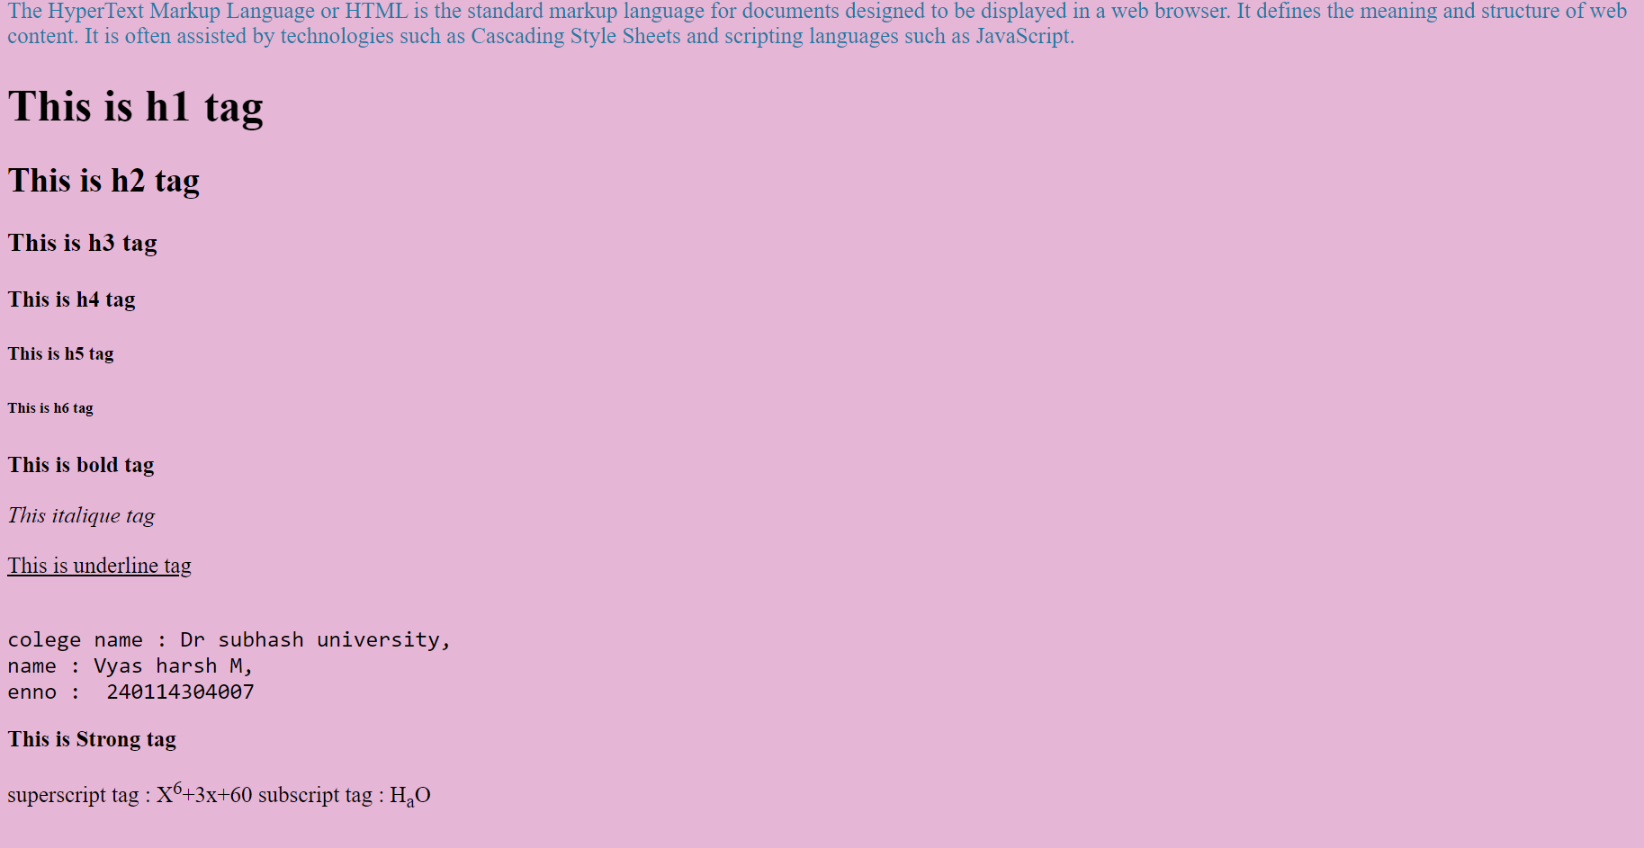

**Practical :- 2**

**Aim:-** **Use hyper link tag to navigate through different web pages as per given sample.**

**Index.html:-**

<!-- using hyper link tag to navigate through different web pages -->

<!DOCTYPE html>

<html lang="en">

<head>

<meta charset="UTF-8" />

<meta name="viewport" content="width=device-width, initial-scale=1.0" />

<title>Document</title>

<!-- font awesome -->

<link rel="stylesheet" href="https://cdnjs.cloudflare.com/ajax/libs/fontawesome/6.4.2/css/all.min.css"

integrity="sha512-

z3gLpd7yknf1YoNbCzqRKc4qyor8gaKU1qmn+CShxbuBusANI9QpRohGBreCFkKxLhei6

S9CQXFEbbKuqLg0DA=="

crossorigin="anonymous" referrerpolicy="no-referrer" />

<!-- bootstrap -->

<link href="https://cdn.jsdelivr.net/npm/bootstrap@5.0.2/dist/css/bootstrap.min.css"

rel="stylesheet"

integrity="sha384-

EVSTQN3/azprG1Anm3QDgpJLIm9Nao0Yz1ztcQTwFspd3yD65VohhpuuCOmLASjC"

crossorigin="anonymous" />

<script src="https://cdn.jsdelivr.net/npm/bootstrap@5.0.2/dist/js/bootstrap.bundle.min.js"

integrity="sha384-

MrcW6ZMFYlzcLA8Nl+NtUVF0sA7MsXsP1UyJoMp4YLEuNSfAP+JcXn/tWtIaxVXM"

crossorigin="anonymous"></script>

</head>

<body>

<center class="mt-5">

<!-- google -->

<h2>Google :</h2>

<a href="https://www.google.com">Click here</a>

<br><br>

<hr>

<!-- yahoo -->

<h2>Yahoo :</h2>

<a href="https://login.yahoo.com/"><img src="yahoo.png" alt="" width="5%"></a>

<br><br>

<hr>

<!-- linkedin -->

<h2>Instagram :</h2>

<a href="https://instagram.com" target="_blank"><img src="images.jpeg" alt="" width="5%"></a>

<br><br>

<hr>

<!-- facebook -->

<h2>Facebook :</h2>

<a href="https://www.facebook.com" target="_blank"><button type="button" class="btn

btn-primary">Facebook</button></a>

</center>

</body>

</html>

**Screenshot :-**

